YEAR 1
Unit 3 GOD HEARS US

Lesson 1: Hannah's Dedication

God Hears Us

GAMES

    - A game of ‘Samuel Whispers’ This is played just like ‘Chinese Whispers’. The children sit around in a circle. One child is chosen to be ‘Samuel’ and make up the whisper (help them to make up a sentence, you could start by passing around what Samuel responded to God when he heard him calling ‘Speak lord for your servant is listening’) If you have a large group you might split them into their age groups and challenge the teams against each other. Make sure you have a list of different whispers to send around.

    - Get the children to run/walk around the room. When you shout numbers they must do the corresponding action. Introduce one or two new numbers at a time otherwise they will be lost before you even begin. Feel free to make up your own actions: those given are simply a starter.
- Touch the floor
- Jump in the air
- Run in an opposite direction
- Clap once
- Clap twice
- Lie on the floor and then get up again
Under 5s:
1 You could use have a range of animal pictures displayed in front of your child (or use different stuffed/hard toy models of animals from home). You then tell them to point at or cover over the picture of an animal when they hear the animals noise. You either play the noise of each animal online or make the noise yourself.
2 You could play I spy with your toddler. colors, sizes, textures, beginning letter sounds, or positional words to give clues. Then the toddlers ask questions or guess until they get it.

* Free Games app on phone or tablet. Search Youth Group Games ‘Tried and tested youth games’.

MEMORY VERSE

‘I praise you because I am fearfully and wonderfully made; your works are wonderful, I know that full well.’ Psalm 139:14 (NIV)

Ways to teach the memory verse

      - Play ‘hangman’ memory verse leaving in all the vowels and the children choose the other letters until it spells out the memory verse. Then repeat the whole memory verse a couple of times all together.

Play ‘catch the verse’. Have a ball at the ready and get the children to stand in a circle. You throw the ball to someone and say the first word of the memory verse, then to the next and so on, each time saying the next word of the memory verse continuing around the circle. Once the children have gone around the circle a few times and got to know the memory verse the next time round if they drop the ball they must sit down until only one remains. (Still saying the memory verse)

      - ‘See-saw’ memory verse. Split the children into two teams, either side of the room. All together as a group get the children to repeat the memory verse until you are sure they know it.
Then they must take it in turns to shout out the memory verse alternative words at a time across the room.
Each team starts with 10 points. Every time the team hesitates they loose a point until the losing team reaches zero.

Under 5s

‘Thank you God for making me so wonderfully.’

Create actions to go along with different parts of the memory verse. You could clasp your hands together and make a praying posture for ‘thank you’, point to the sky for ‘God’, then point to yourself when saying ‘me’ and put your thumbs up when saying ‘wonderfully’. You challenge your toddler to whisper or shout the verse and increase/decrease the speed at which you say it. You can talk about how we speak in many different ways and how you are going to read a story about where God speaks to a boy.

BIBLE BLAST
KEY PASSAGE: 1 SAMUEL 1 & 2
You can read this story from your child’s bible or use the
Alternative talk/VIDEO see JIGSAW DDYC Pinterest site ‘Year 1 Unit 3 GOD HEARS US’
Once you have read the bible story ask your children some ….

KEY QUESTIONS

- Do you think that you can talk to God about anything?
- Do you think He wants you to pray about things that make you angry or sad? Has God ever answered one of your prayers?
- What happens if we don’t see God answering our prayers? Does that mean He didn’t listen?

Under 5s

If you could ask God for anything in the whole wide world, what would you like right now?

Do you think you can talk to God about anything? What do you talk to him about?

Do you think you can talk to God about things that make you sad?

Do you think Hannah was happy that she prayed to God?

GET CREATIVE

For little ones with a short attention span these activities/ideas may be a helpful way to explain the meaning of the story:

Use a selection of cardboard tubes and boxes (alternatively you could use lego bricks) and together with your toddler make a model of the temple where Hannah prayed to God. Explain how Hannah was very upset and God heard her prayer.

Select a range of items for your kids to drop either into a basin of water or a sink of water. Get them to listen to noise heavier objects make in comparison to loud objects. You can use this to explain how God listens to all our prayers, whether they are loud or whispers, or happy prayers or sad prayers. He loves to listen when we talk to Him.

PRAY

Ask the children to close their eyes. Tell them that you are going to help them pray – sometimes there are so many things that we would like to tell God that’s it’s hard to remember them all! So I am going to give you an idea, and then inside your head, you can tell God these things.

First of all, say hi to God! (pause so children can respond silently) Tell Him about what you’ve learned today.
Thank Him for something that makes you happy.
Now, tell God about something that has made you sad. Ask Him for help with something you are worried about.
Tell God about your best friend.
Now, think of somebody you know who needs help, and ask God to help them.
God loves to laugh, so tell Him your favourite joke!
If there is anything else you’d like to tell God, you can tell Him now.
Now, last of all, thank God for hearing our prayers. And let’s all say ‘Amen!’ out loud! Amen!

Under 5s

Thank you God, that when we speak to you, you hear our prayers. Help us to talk to you about everything, even things that make us sad. Help us to listen to you and trust you. Amen.

PRAYER JAR
[Try and have one made to show the children]

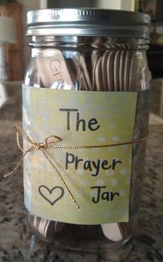
MATERIALS:

Glass jar per child (ask well in advance for parents/congregation/friends to collect)
  - Glass pens/markers
  - stickers (all kinds)
  - sticky blank labels to write/draw onto
  - Lolly sticks
  - Felt tip pens (to write on the lolly sticks)
  - ribbons, string etc
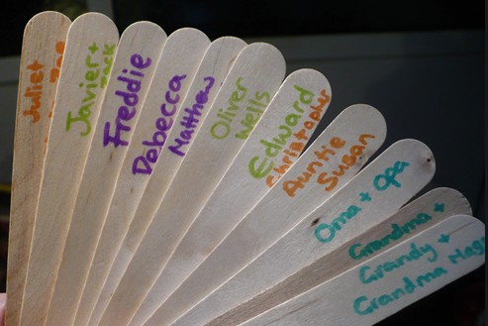
  - other craft materials

INSTRUCTIONS:

See JIGSAW DDYC Pinterest site ‘Year 1 Unit 3 GOD HEARS US’

Give each child a glass jar. Let them know that they will be making a prayer jar for all their prayers and requests to go in on the Lolly sticks.
- Let the children decorate their prayer jar with stickers, blank stickers with pictures and words written on, ribbons, other materials etc
- Give each child 3 lolly sticks to start. Let them write prayers, or names
of people on the them and place into their prayer jar.
- Make sure to date the prayers to remind the children of when they prayed for that person or situation.
- Use the discussion questions in the ‘Response’ time to chat together.

