YEAR 1
Unit 3 GOD HEARS US

David the Future King

David the Future King

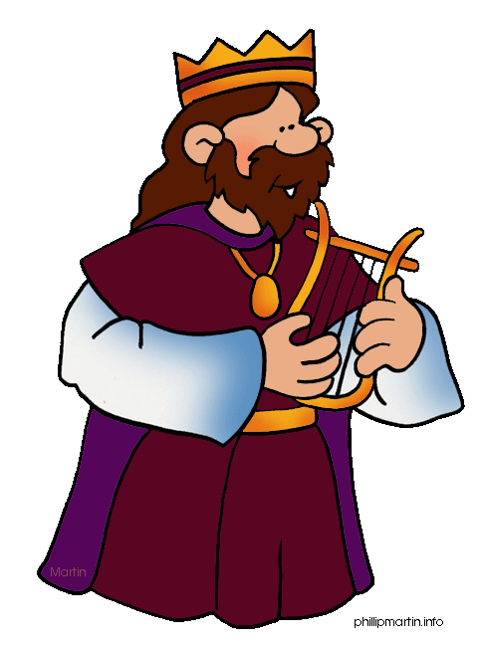

GAMES

- Ask the children to sit with their eyes closed. Ask them to raise their hand when they think the amount of time you mention has passed. See who can get most accurate results! Do 10 seconds, 30 seconds, 1 minute and 2 minutes.
Probably the children will underestimate the length of time. Make the point that sometimes, time can seem very long. Our story tells us about David as a boy being anointed to be King but it was many years later before he actually became King!
- Give everyone a fruit pastille and have a competition to see who can suck it for the longest without chewing… It’s much harder than you think!

Under 5s:
1. If your little ones enjoy dressing up, get them to dress up as princes or princesses. You can have a royal dinner party using fake teacups/saucers and some real food if you decide to play over lunchtime. Alternatively, you could create a castle together with cardboard/chairs etc.

* Free Games app on phone or tablet. Search Youth Group Games ‘Tried and tested youth games’.

MEMORY VERSE

‘When I am afraid I put my trust in you. Ps 56 v 3

Ways to teach the memory verse

- Say the verse out loud a few times.

- This time say the verse in a whisper, then say it in a funny voice, then try saying it in a sad voice. Finally see if you can say the verse without the words.

BIBLE BLAST
Who can remember the man we talked about last week?
Samuel grew up to be a very important man, with a very important job. He became a prophet – does anyone know what that means?
It means that he heard messages from God. God spoke to him just as He did when Samuel was a kid, but this time, He told Samuel things and asked him to pass them on to the Israelites, God’s people. And God had a very special task for Samuel. Samuel had to find the next king of Israel, the person who would lead God’s people. What kind of person would you pick, if you had to find a king?
Well, God had somebody in mind, and we’ll see what he was like soon. He told Samuel that the new king would be the son of a man called Jesse.
To tell this story, I need some help from all of you. There are some words that I am going to repeat a lot, and I would like you guys to help me out by doing some actions to these words. One of the words is ‘strong’ – can you make a very strong pose, like you have lots of muscles, when I say ‘strong’? When I say the word ‘tall’, can you stretch up to be as tall as you can? And when I say the word ‘handsome’ – can you all say ‘ooooooh!’ And the very last one – when I say “and God said”, I’m going to take a deep breath and I would like you to do the loudest drum roll you can.
So off Samuel went to find the King whom God had chosen. When he got to Jesse’s home, he discovered that Jesse had not one, not two or three, but EIGHT sons. Jesse introduced Samuel to his first son, Eliab. Eliab was tall (action), and strong (action), and handsome (action), and Samuel thought “He’s perfect! God, this guy is tall (action), strong (action) and handsome (action) – surely he must be the next king!”
And God said... (drumroll)... “No, not this one!”
Then Jesse introduced Samuel to his second son, Abinadab. Abinadab was also strong (action), tall (action) and handsome (action), and Samuel thought “ God, Abinadab is also strong (action), tall (action) and handsome (action) – surely he must be the next king!”
And God said ... (drumroll)... “No, not this one!”
Then Samuel met Jesse’s third son, Shammah. And his fourth son, and his fifth and sixth and seventh sons – all of whom were tall (action), strong (action) and handsome. But each time, God said... (drumroll)... “No, not this one.”

By this point, Samuel was a bit confused. Why hadn’t God picked one of these brothers? To him, they seemed perfect! Frustrated, he asked Jesse if he had any other sons, and Jesse said, “Well, my youngest son David is out looking after the sheep, but HE won’t be the next king. He’s too small, and he’s not as strong as his brothers. You won’t want him!”

David wasn’t as strong (action) as his brothers, nor as tall (action), and he was the baby of his family. But God didn’t care about those things. He saw that David had a kind heart and knew that David would care just as much for his people as he did for the sheep he looked after. He saw that David was brave and true and that he loved God. So when Samuel met David, and asked God if he was to be the new king, God said... (drumroll)... “Yes, this is the next king of my people.
David was only a small shepherd boy. He wasn’t as strong or as tall or as cool as his brothers, but God didn’t care about that. He saw that David’s heart was brave and true and kingly, and that was all that mattered to him.
That shepherd boy, David, went on to become the greatest king Israel had ever seen – he was a great warrior who even slayed a giant!

Application:
So even if you’re not as big or strong or as clever as other people, that’s not what really matters to God.

God knows everything about you – the things that make you laugh, how much you love your family and friends, the kindness in your heart and those are the important things.

He doesn’t just pick the strong people to do his work, but little people like you and me because he looks at what is inside us. How we treat other people. How we show God’s love to our family, friends and others.

Let’s pray

Dear God thank you that you chose us. You love us for who we are and want us to follow you in our lives everyday.
Amen

Once you have read the bible story ask your children some ….

KEY QUESTIONS

Who was Samuel?
Why did God choose David to be the next King of Israel?
God knew that some of the best things about David were that he was kind and caring. What are the good things about each of us?
What things do you think God might like to see in our hearts?

Under 5s

Who is your favorite Disney princess/hero?

Who was Samuel and what did he do?

If you were a king/queen for a day what would you do?

Why did God choose David to be the next King?

What do you think God wants us to be like? Does he want us ot be kind and caring like David? How can we be like that?

GET CREATIVE

For little ones with a short attention span these activities/ideas may be a helpful way to explain the meaning of the story:

You could ask your toddler to get a selection of toy figures/teddies and arrange them in order of height/size, with the smallest being David. You can act out the scene of Samuel anointing David and explain how, though his brothers were taller and bigger like the other teddies, God didn’t look for a King based on their appearance but based on their love for Him.

You could plant seeds in a pot with your toddler. Watch the seeds progress each day and explain how, just like it takes time for things to grow, David had to wait a long time till he was King after Samuel said he would be.

Check out our Kidschurch Facebook page to see an interactive toddler story based on David as a shepherd which your little ones can watch and join in with.

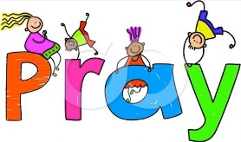

REFLECT AND PRAY

Give the children some hearts that they can write on.
Ask the children what they think the good qualities that would please God are.
Encourage them to write (or draw) these things on the heart, and pray that God will help them to develop these.

Pray

Father God, thank you that you love us for who we are! We’re so glad that you look at what is on the inside, not the outside. Help us to grow in all of the good things we have written about, so that you might look at our hearts and be pleased with what you see. Amen.

CRAFT

Colouring picture – Samuel anoints David
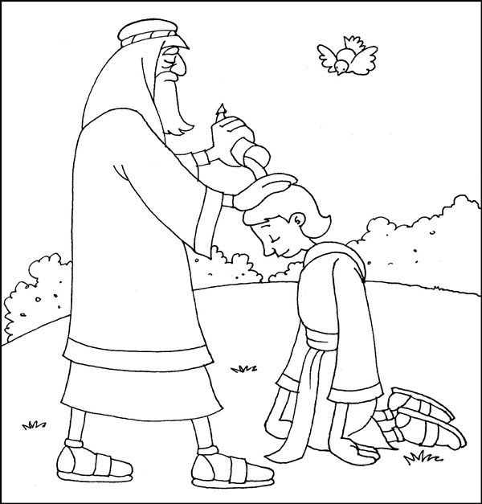

Decorate a crown

