YEAR 1
Unit 1 GOD’S WORLD

Lesson1: God made the world

God’s World
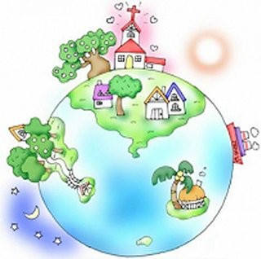
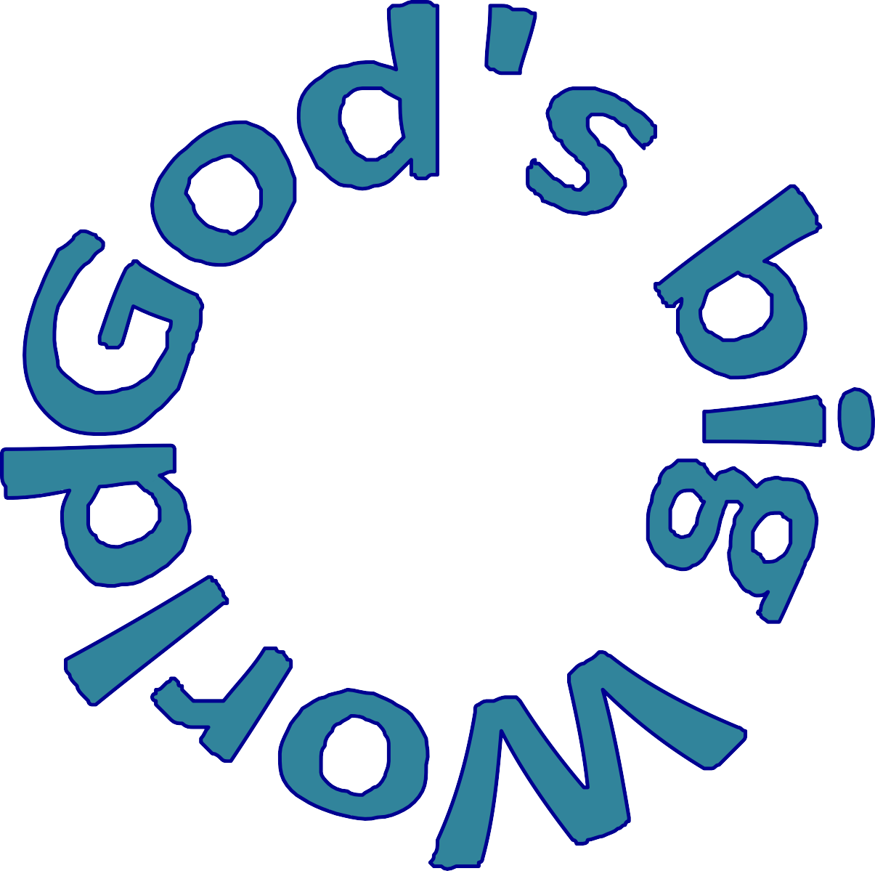

YEAR 1
UNIT 1: GOD’S WORLD

Lesson 1: God made the world
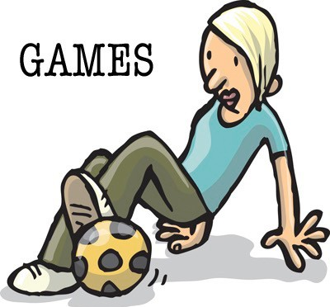

GAMES

Ideas for fun ways to introduce the lesson.

    - Play ‘duck, duck, goose’ but using the words ‘Sun’, ‘Moon’, ‘Stars’, ‘World’. (Creation lesson) Sit the children in a circle facing inwards with someone walking around the outside. They walk past and tap the heads of the children with the word ‘Sun’, ‘Moon’, Stars’ ‘Sun’, ‘Moon’, Stars’ ‘World’ When they tap a head with ‘World’ that person has to chase them around the circle and catch them before they get round to sit in their vacant spot.

    - Pictionary: One person gets the name of the different things that God created: birds / fish / trees / plants / animals / stars / sun / humans. They draw them for the group and when guessed another person comes to get the next word.

Under 5s:
- Get different pictures of different animals and see if you’re toddler can guess the animal and the noise it makes.
- Write down on a piece of paper a list of different nature themed items you have in your garden e.g. leaf, grass, wood, stone etc and go on a scavenger hunt to find the items. Once you’ve found each item you can tick it off the list.

* Free Games app on phone or tablet. Search Youth Group Games ‘Tried and tested youth games’.

YEAR 1
UNIT 1: GOD’S WORLD

Lesson 1: God made the world

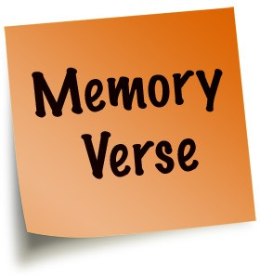
MEMORY VERSE

‘In the beginning God created the heavens and the earth. “Genesis 1v1

Ways to teach the memory verse

      - Have outline shapes of World, Sun, Moon, Star, fish, bird, tree and person. Cut out outlines and write parts of the memory verse on each piece. Hide the pieces up around the room. Ask the children to find the pieces and bring them to you. Once you all the pieces unjumble the memory verse. Remind them that they are learning all about God’s creation and world.

      - See if you can make up actions for the memory verse.!

YEAR 1
UNIT 1: GOD’S WORLD
LESSON 1: GOD MADE THE WORLD

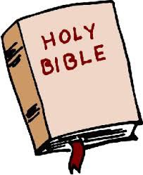
BIBLE BLAST
KEY PASSAGE: GENESIS CH 1-­2v4
Alternative talk/VIDEO see Pinterest JIGSAW DDYC board UNIT 1 GOD’S WORLD

Our story today is found in this book.(Show a Bible) Can anyone tell me what makes this book special? Yes it’s the Bible. Our story is special because it comes from Gods word – the bible.
We find our story at the very beginning of the Bible in the very first book. Does anyone know what the first book of the Bible is . . . that’s right it’s Genesis.
And Genesis is found in the . . . Old Testament – that’s all the books written before Jesus was born. So we begin at Genesis chapter 1 – the very beginning, God created the heavens and the earth.

Close your eyes. What do you see? Nothing? (open your eyes)
Well in the beginning, there was nothing. Everything was dark.
There was no land or water or plants or animals or even people. There was nothing. Then God said, “Let there be light,” and there was light!
God separated the light from the darkness.
He called the light ‘day’ and the darkness ‘night’

And God saw that it was good. DAY 1

Then God separated the waters. The water below and the water above which was called sky

And God saw that it was good. DAY 2

So God gathered up the water below the sky to make seas and create the land .
God separated the land from the water.
The ground was empty and bare. So God decided to make plants. He covered the ground with plants. God made grass and trees and bushes. God made flowers of all different colours. God made plants and fruit and vegetables, all good things to eat. He made the plants that we use to make baskets and clothes. God looked at all He had made.

And God saw that it was good. DAY 3

Later, God made some special lights to shine in the sky to separate night and day
What light shines in the sky in the day? – the sun
What lights shine in the sky in the night? -­‐ the moon and the stars
God was thinking of us when He made day -­‐ He knew we needed time to work and play and he made the night so that we would have time to sleep.

And God saw that it was good. DAY4

The world was very beautiful, but it was very quiet.
Why? Because there were no animals! So God decided to make things to live in the beautiful world He had made. First God made the birds. He made big birds and little birds. He made red birds and blue birds and brown birds, all sorts of birds. Then God made the sea creatures. He made big fish and little fish and colourful fish and plain fish. God made octopus and seahorses and crabs. God made everything that lives in the water.

And God saw that it was good. DAY 5

Now it was time to make some animals for the dry ground. What kinds of animals do you think he made? God also made some animals especially to help us. He gave us animals to give us milk, to give us meat and even to help clothe us.
God was thinking of us when he made the world. He filled it with good things. He even filled it with us – he made people!

And God saw that it was VERY good. DAY 6

God was very busy creating and after everything was completed God took some time out and rested on the 7th day. God blessed this day and said it was very special, a day to spend time with God, a holy day.

Application:
The bible is God’s word to us, as we read the bible we learn more about God and how we should live our lives for God.
The bible tells us that God created the whole world; he made it all to show his glory and power. God created us to enjoy the earth and to be God’s helpers to tell others about God and to show God’s love and care for others. He asks us to look after the world and be wise with everything we have.
God requires us to be his example on earth, to make God pleased with us so that we can say ‘And God saw that it was good’

Let’s pray

Dear God thank you that you made the whole world. Thank you that you made me and others to show your wonder to others and to tell the good news of Jesus to other people.
Amen

YEAR 1
UNIT 1: GOD’S WORLD
LESSON 1: GOD MADE THE WORLD

KEY QUESTIONS

Who created the world?
How can you become more like God?
What do you do that God would be pleased with? How can we look after our world?

Under 5s
- What do you like seeing when you go for a walk? DO you like seeing the sunshine, the animals in the fields, different people etc?
- Who created the world?
- Did God like the world when he created it?
- What do you think God would like us to do or be like?

GET CREATIVE

For little ones with a short attention span these activities/ideas may be a helpful way to explain the meaning of the story:

- Using flowers/twigs and soil etc set up a miniature garden of Eden either on a tray or in a corner of your own garden. You can then use small figures to act out Adam and Eve taking care of the garden and animals.
- Fill a basin with water and another basin with sand and another basin with stones and a rug that’s furry and allow the toddler to touch the material in each basin (under supervision unless you want the kitchen/living room to turn into a beach). You can explain each step of creation using these different basins.
- Using play dough create different animals or people.
- Pick a variety of different leaves and paint one side of them and then press it onto a piece of card. Repeat this process to create a cool picture. You can explain how there are lots of different kinds of leaves, just like God created everyone different and unique.
- You could turn off all the lights in the evening and then explain how everything was dark in the beginning and then turn on a torch or lamp and explain how God then created light.

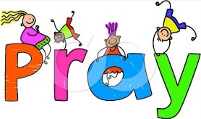
REFLECT & PRAY

1. Roll play dough into a ball to represent the world
2. Ask the children to say ‘Thank you’ prayers for some of the amazing things
God has created.
Then tell them to make a person, representing themselves.
Ask them to say thank you to God for their family and friends and themselves!

CRAFT

Give the children access to junk materials and encourage them to use whatever bits and pieces they want, to create an animal. It can be a recognisable existing animal, or one from their own imagination.
Set them to work on their own, or in pairs, or even to work as a whole group to make a giant "Junk Monster".

Creation crossword - see below.
When complete, it can be painted if you wish. 