The Easter Activity
Pack for Families 2020

Palm Sunday
Good Friday

Easter Sunday

Intro
Notes for Parents

Welcome to The Easter Activity Pack for Families. It covers 3 of the main Holy Week stories:

- Palm Sunday - Celebration

- Good Friday – Crucifixion

- Easter Sunday - Celebration

For each session there is:
- A story to read together from the Bible
- Discussion questions to get you thinking
- Fun activities
- Puzzles to solve
- Colouring in sheets
There are lots of different activities in each section.
Don’t feel pressure to do them all - the choice is there to give you options based on your child’s age or ability as well as the resources you have to hand.

I am aware that many people will not have access to extra materials so I have tried to come up with activities and crafts you can do at home with what you have.

Worship
On YouTube there are some great songs available to sing along to.
Check out the Kidschurch playlist on spotify (link on Facebook page).

Here's a great link to Christ Church Abington's playlist of the songs they sing in their 5-11s group called ‘CCA Sunday Songs’ from Heather Hughes (Children's Minister)
https://www.youtube.com/playlist?list=PLbJbdv9jRUdukmFSLH5MgqgVxXhEN3z7V

Feedback
You might want to encourage other families with things you have made and done by contacting your Children's Worker or Sunday school leader or posting photos of them on platforms like Facebook, Instagram, etc. (Make sure all permissions are granted for this)

Prayers & Support
If you need any further support or prayers then please contact the our helpline, Minister or Young Family Worker.

Many thanks goes to Heather Hughes Children’s Minister for Christ Church Abington for ideas and sourcing activities and signposting
to great sites.© Heather Hughes, 2020, for personal use only.

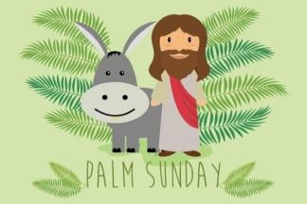
BIBLE STORY
- Read from the page here.
- Read and play the activities from The kids Bible App (download for free) ‘The Donkey & the King’ www.bible.com/en-GB/kids
- Read from your children/family Bible.
Bible Reading: Matthew 21:1-21(NIV) – Jesus comes to Jerusalem as King
As they approached Jerusalem and came to Bethphage on the Mount of Olives, Jesus sent two disciples, saying to them, “Go to the village ahead of you, and at once you will find a donkey tied there, with her colt by her. Untie them and bring them to me. If anyone says anything to you, say that the Lord needs them, and he will send them right away.”
This took place to fulfill what was spoken through the prophet:
“Say to Daughter Zion,
‘See, your king comes to you,
gentle and riding on a donkey,
and on a colt, the foal of a donkey.’”
The disciples went and did as Jesus had instructed them. They brought the donkey and the colt and placed their cloaks on them for Jesus to sit on. A very large crowd spread their cloaks on the road, while others cut branches from the trees and spread them on the road. The crowds that went ahead of him and those that followed shouted,
“Hosanna to the Son of David!”
“Blessed is he who comes in the name of the Lord!”
“Hosanna in the highest heaven!”
When Jesus entered Jerusalem, the whole city was stirred and asked, “Who is this?”
The crowds answered, “This is Jesus, the prophet from Nazareth in Galilee.”

Chat (under 5s)
- Have you ever been to a parade or a special party? What was it like?
- The disciples were singing songs of praise as they walked along and the crowd sang too. What do you think we would be singing if Jesus was here now?
- The royal family usually wear special clothes for special parades, but Jesus wore ordinary clothes and rode on the back of donkey. Why do you think he did that? Why were they calling him King?

Chat
- Talk about how the different people in the story felt. The disciples, the people in the crowd, Jesus.
- Have you ever been to a parade or a big celebration. How did it feel?
- The disciples were singing songs of praise as they walked along and the crowd sang too. What do you think we would be singing if Jesus came now?
- Jesus travelled on a donkey, not the way a king would usually travel. What made Jesus different?
- Talk about what it means to follow Jesus. Was it easy for the disciples?
- Jesus is called the King of kings. Can you think of any other names for Jesus? (Hosanna – ‘save us’, the Saviour) Write them down on a big poster.

Make
Activities

- Have a go at making some ‘walking feet’. You might want to write the words ‘Following Jesus’ on them. https://www.youtube.com/watch?v=L5nkP-6UBa8
- Cut out some green leaves and some paper coats. Make a wreath to hang up and decorate your house. Put the word ‘Hosanna’ on it, or another praise word.
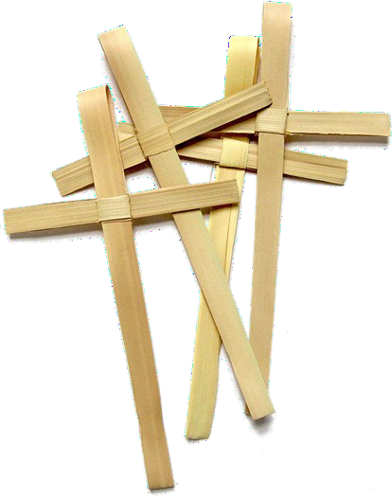
- Make some characters and put them on lolly sticks or temporarily on cutlery handles. Make a puppet show. Don’t forget to make a donkey! Make a stop motion video!
- It’s traditional to have Palm Crosses on Palm Sunday. Make a Palm Cross out of strips of a long leaf from the garden, or using paper. https://www.youtube.com/watch?v=JcmeCOf-b4k
- If you have access to paint or ink pads try making a donkey Hosanna poster. Use your feet and hands!
- Make some handprint palm leaves, cut them out and stick them onto a lolly stick, straw or stick and have a procession around your house waving them and singing
- Make a donkey mask (See next page for design)

Do
- Go for a walk if you can, or if you have a garden you could go there. Listen to the birds and the rustling of the leaves. Think about how it felt getting ready for the parade. Turn your walk into a prayer walk, thanking Jesus for being our King and sharing together what your favourite things are about Jesus.
- Sing a worship song together
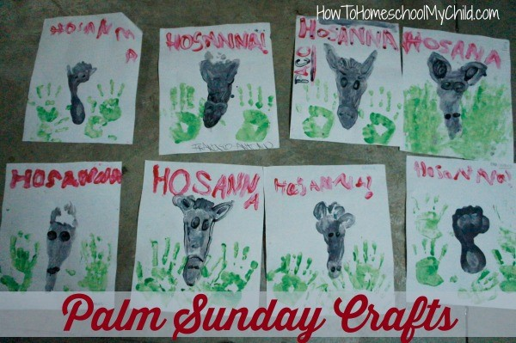
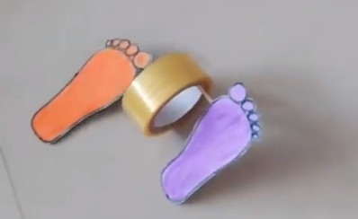
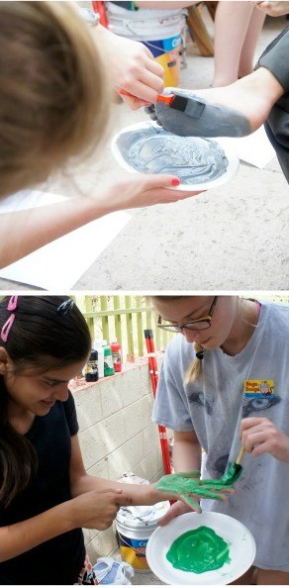
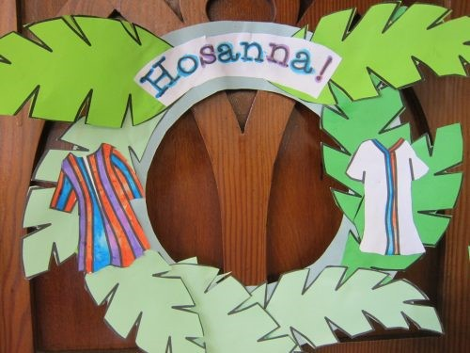
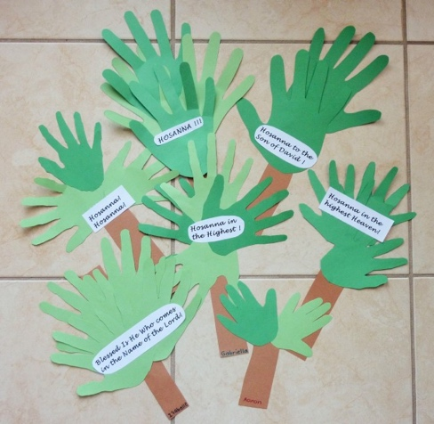
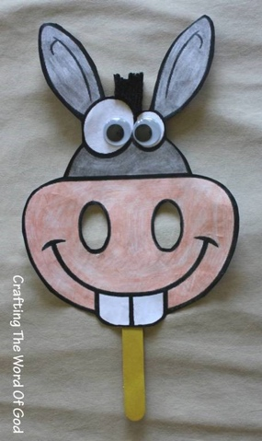
- The people were crying out for someone to save them. Talk about the kind of people who are struggling at the moment and need someone to
save them. Pray for them. You might want to cut out some leaves and write their names on them. Hang them up somewhere to make a prayer tree.

Activities
Under 5s

Many of the crafts/activities in the previous page will work for toddlers, but we have more activities specifically for them below:

- The children could dress up in fancy princess dresses or crowns. Alternatively you could make a crown using card or gown using an old duvet sheet. You can use this activity to explain how Jesus was different to other kings and queens in that He didn’t wear any fancy clothes and he rode on a simple donkey.
- Go on an outdoor scavenger hunt in the garden and get the children to pick lots of different kinds of leaves. Using wax crayons create leaf rubbings on a piece of card or paper. You can use this activity as a chance to explain how the people used enormous leaves that they could wave, like we do with flags, to celebrate and welcome Jesus.

- Collect some stones from the garden and paint them. Use can use this activity to explain how Jesus said that even if the people on the crowd didn’t praise him, the stones would.

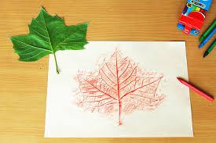
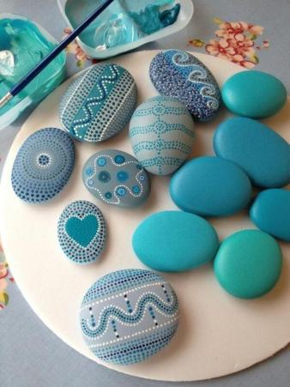
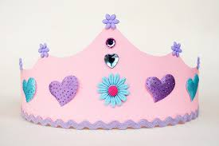
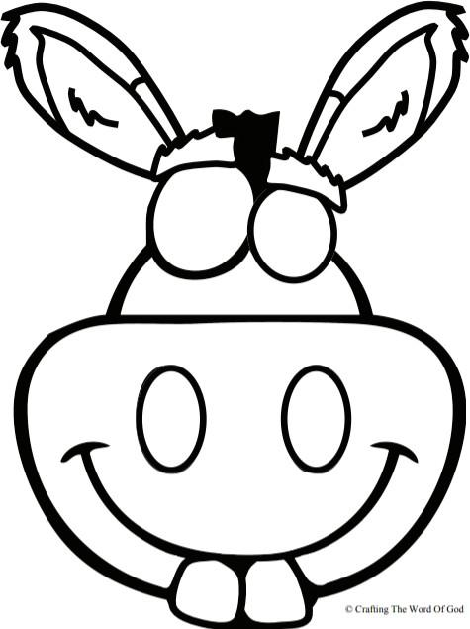
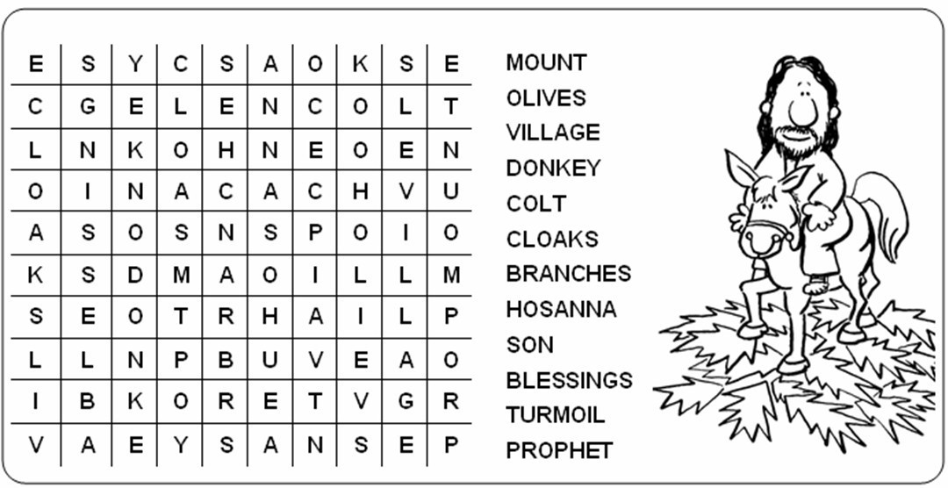
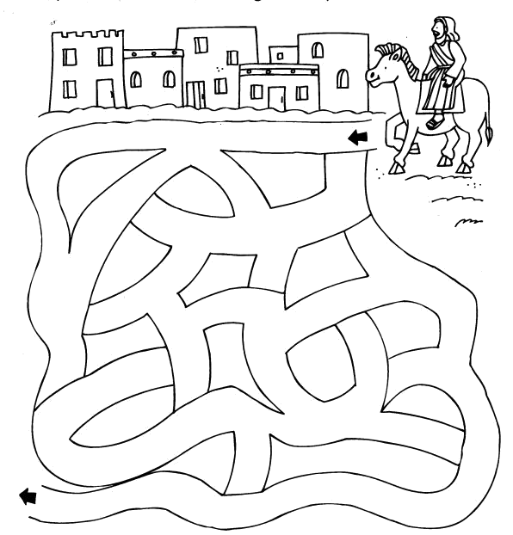
Puzzles

Colouring in
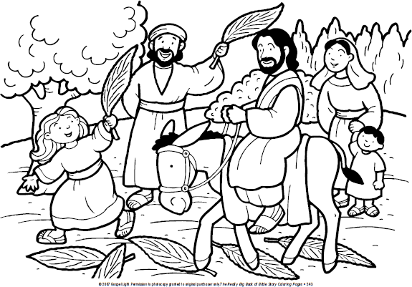
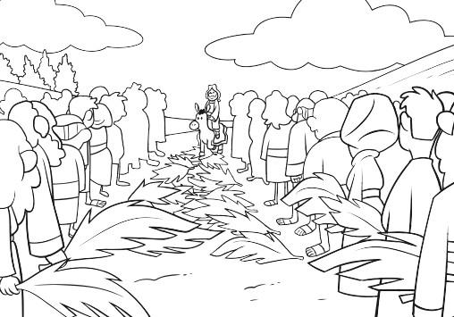

BIBLE STORY
- Read from the page here.
- Read and play the activities from The kids Bible App (download for free) ‘It is finished!’ www.bible.com/en-GB/kids
- Read from your children/family Bible.
Bible Reading: Matthew 27:35-50 (NIV) – The death of Jesus
‘When they had crucified him, they divided up his clothes by casting lots. And sitting down, they kept watch over him there. Above his head they placed the written charge against him: THIS IS JESUS, THE KING OF THE JEWS. Two rebels were crucified with him, one on his right and one on his left. Those who passed by hurled insults at him, shaking their heads and saying, ‘You who are going to destroy the temple and build it in three days, save yourself! Come down from the cross, if you are the Son of God!’ In the same way the chief priests, the teachers of the law and the elders mocked him. ‘He saved others,’ they said, ‘but he can’t save himself! He’s the king of Israel! Let him come down now from the cross, and we will believe in him. He trusts in God. Let God rescue him now if he wants him, for he said, “I am the Son of God.”’ In the same way the rebels who were crucified with him also heaped insults on him. From noon until three in the afternoon darkness came over all the land. About three in the afternoon Jesus cried out in a loud voice, ‘Eli, Eli, lema sabachthani?’ (which means ‘My God, my God, why have you forsaken me?’). When some of those standing there heard this, they said, ‘He’s calling Elijah.’

Immediately one of them ran and got a sponge. He filled it with wine vinegar, put it on a staff, and offered it to Jesus to drink. The rest said, ‘Now leave him alone. Let’s see if Elijah comes to save him.’ And when Jesus had cried out again in a loud voice, he gave up his spirit.

Under 5s
Keep this story simple with under 5s. You can use a version from a bible for young children (e.g. Jesus story book bible), which may go something like this (adapted from Becky Mays, Gods story for under 5s)
While Jesus was on earth, he spent a lot of time with close friends, teaching them about God and how to live life his way. One evening Jesus and his disciples were having a meal together when Jesus told them that He wasn’t going to be around for much longer. Jesus friends’ were very confused.
When they had finished the meal Jesus and His disciples went to a hillside so that Jesu could talk to his father, God. Some soldiers came with swords and other weapons and took Jesus away.

The rulers didn’t like what Jesus said and the things He did, and they did not believe what Jesus taught about God. So they put Jesus on a cross and He died. His disciples were very sad.

Chat
- On Palm Sunday the crowd cheered ’Hosanna’ but only a few days later they were shouting ’Crucify him’. Why do you think they changed? How does it make you feel?
- Some of Jesus’ friends were in the crowd when this shouting was happening. Have you ever been in a situation where people were saying things you didn’t agree with? Were you able to speak up?
- The disciples were afraid. Is there anything that you are afraid of? The Coronavirus? Ask God (and your family) for help with those fears. You might like to write them on a cross.
- Talk about what sacrifice means. Have you ever sacrificed something?
- Jesus is called our ‘Saviour’. What does that mean?- Jesus came to save the World, to save us. How does that make us feel?

Chat (under 5s)
- On Palm Sunday the crowd were happy to see Jesus and praised him. But later they shouted for him to die? Why do you think they changed? How does it make you feel?
- Some of Jesus’ friends were in the crowd when this shouting was happening. How so you think they felt? Have you ever heard someone say something mean about someone you love?
- The disciples were afraid. Is there anything that you are afraid of? Ask God (and your family) for help with those fears. You might like to write them on a cross.
- Talk about what sacrifice means. Have you ever sacrificed something?
- Is there something you love, that’s very precious to you? Talk about how Gods love for us is so much more precious and Jesus showed us his love by dying for us.

Activities

Make
- Try these crafts. If you don’t have the kit parts then try using twigs and leaves from your garden. https://www.youtube.com/watch?v=04qtzvQrqtM

- Make a cross using silver foil. Put something underneath it like cardboard and dent it gently using a coin or the end of a spoon. You’ll need to be gentle.

- The cross template below can be decorated either by using paint/ink and fingerprints or just simply by colouring or use it for the prayer activity.

- Make a sunset cross. Cut strips of coloured paper and glue them to a piece of A4 paper. Cut a cross shape out of a second piece of white paper/card. Glue the 2 together. Alternatively, instead of sticking the second piece of paper/card on top you could find some dark paper and cut a hill and a cross out.

Do
- Just before Jesus died he had a special meal with his friends. They shared bread and wine together. Enjoy a meal with your family and talk about the Last Supper. If you’ve got some bread you might want to share it together and talk about what the bread represents.

- Even on the cross Jesus forgave the people crucifying him. Ask God to show you if there is someone that you need to forgive. Hold onto a stone as you think about that person, then let it go into a bowl of water as you let go of hurt feelings.

- Message a neighbour or a friend who you think might be lonely or struggling at the moment. See if there is anything they need. When you’ve finished, pray for them.

- Listen to a reflective worship song.

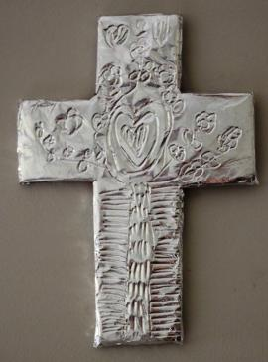
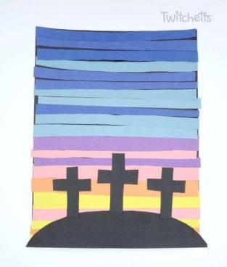
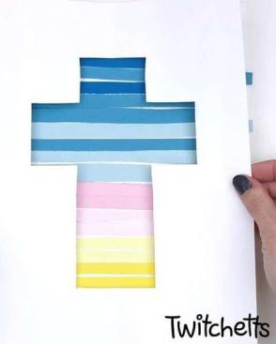

Activities
Under 5s

Many of the crafts/activities in the previous page will work for toddlers, but we have more activities specifically for them below:

- With playdough create a ‘happy face’, ‘sad’ face, ‘confused’ face etc and talk about different parts of the story and how the people would have been feeling.
- Pour some sauce over your sink (or if your sink is like mine there will already be plenty of dirt over it already). Get a sponge and using it and water get your toddler to clean the sink. You can use this activity to explain to them how Jesus died for us because he loves us so much, and he wants to clean our hearts by taking the punishment for all the bad things we do. You could also cut a sponge into a heart shape, pour sauce over it and wash out the sauce to illustrate the point.

- Build a cross out of lego/duplo blocks as a way of helping explain the story.

- The cross template below can be decorated either by using paint/ink and fingerprints or just simply by colouring or use it for the prayer activity.

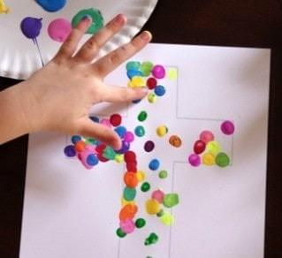

Cross outline to use as a prayer activity. (Or you could just draw this out onto a page)

Puzzles

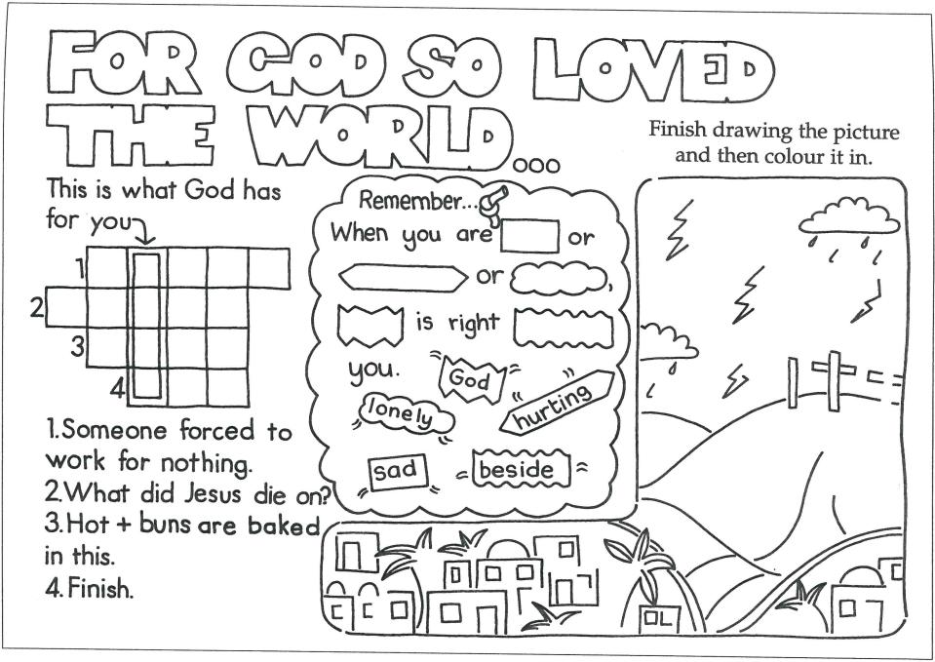

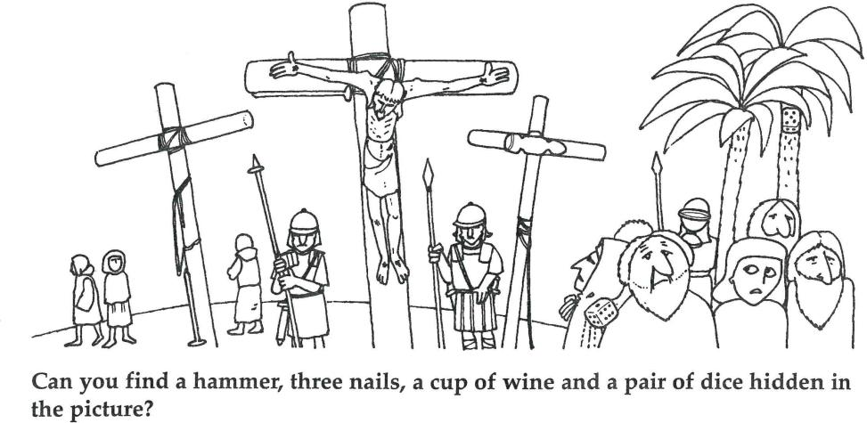

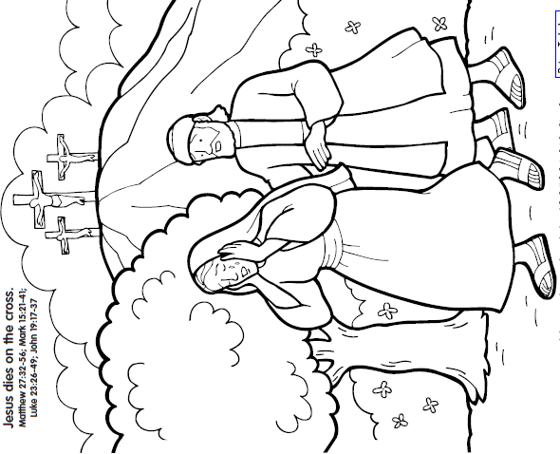
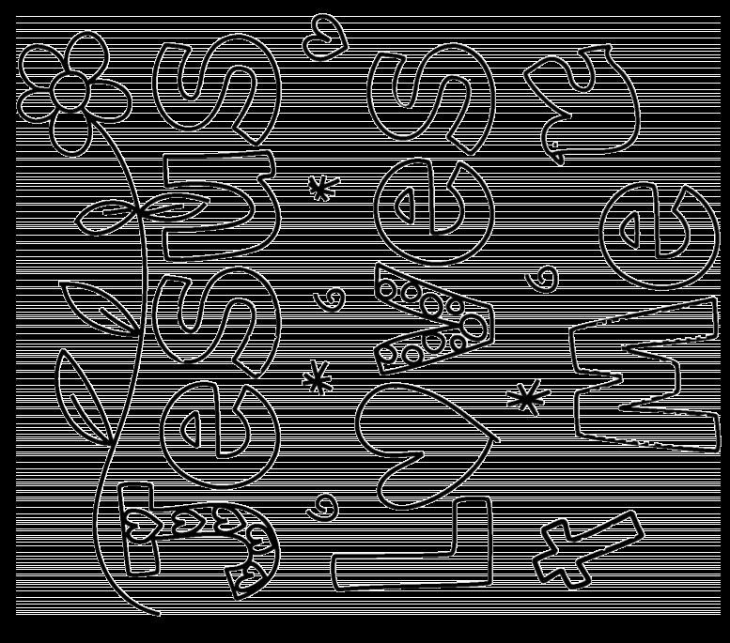
Colouring in
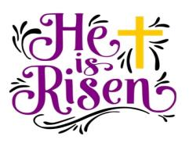
BIBLE STORY
- Read from the page here.
- Read and play the activities from The kids Bible App (download for free) ‘The Empty Tomb’ www.bible.com/en-GB/kids
- Read from your children/family Bible.
Bible Reading: Matthew 28:1-10 (NIV) – Jesus Has Risen
‘After the Sabbath, at dawn on the first day of the week, Mary Magdalene and the other Mary went to look at the tomb. There was a violent earthquake, for an angel of the Lord came down from heaven and, going to the tomb, rolled back the stone and sat on it. His appearance was like lightning, and his clothes were white as snow. The guards were so afraid of him that they shook and became like dead men. The angel said to the women, ‘Do not be afraid, for I know that you are looking for Jesus, who was crucified. He is not here; he has risen, just as he said. Come and see the place where he lay. Then go quickly and tell his disciples: “He has risen from the dead and is going ahead of you into Galilee. There you will see him.” Now I have told you.’ So the women hurried away from the tomb, afraid yet filled with joy, and ran to tell his disciples. Suddenly Jesus met them. ‘Greetings,’ he said. They came to him, clasped his feet and worshipped him. Then Jesus said to them, ‘Do not be afraid. Go and tell my brothers to go to Galilee; there they will see me.’’

Bible Reading: John 20:24-29 (NIV) – Jesus appears to Thomas
Now Thomas (also known as Didymus), one of the Twelve, was not with the disciples when Jesus came. So the other disciples told him, “We have seen the Lord!” But he said to them, “Unless I see the nail marks in his hands and put my finger where the nails were, and put my hand into his side, I will not believe.”

A week later his disciples were in the house again, and Thomas was with them. Though the doors were locked, Jesus came and stood among them and said, “Peace be with you!” Then he said to Thomas, “Put your finger here; see my hands. Reach out your hand and put it into my side. Stop doubting and believe.” Thomas said to him, “My Lord and my God!” Then Jesus told him, “Because you have seen me, you have believed; blessed are those who have not seen and yet have believed.”

Under 5s
Like, with the story about Good Friday, keep this story simple with under 5s. You can use a version from a bible for young children (e.g. Jesus story book bible) which may go something like this (adapted from Becky Mays, ‘Gods story for under 5s’):
After Jesus died, he was put into a tomb and a heavy stone was laid across the front so no one could get in. But three days later some friends went to visit his grave. They found the stone was rolled away and Jesus wasn’t in the tomb anymore. He wasn’t dead, he had come back to life. Jesus’ friend were back together with their very special friend and they were very happy.

Chat (unders 5s)
- What is the best news you’ve ever heard? Tell me something that makes you really happy?
- What did the Angel tell the woman when she went to Jesus tomb and why do you think she was so happy?
- Does hearing that Jesus is alive make you happy? Why?
- Do you believe that Jesus died for us, but came back to life?
- How can we know that Jesus really is alive and everything He says is true? - (what we read in the scriptures, people sharing stories with us, miracles and healings, our own experiences, God speaking to us in various ways etc.) Share about Something God has done for you.

Chat
- Why were the women going to the tomb?
- What did the Angel tell the woman?
- Why is this Good News for us?
- Why were the disciples hiding with the door locked?
- What did Thomas say? Why do you think he felt like that?
- In the last verse Jesus talks about people who have not seen and yet have believed - that’s us! Do you find it easy to believe in Jesus?
- How can we know that He is true? - (what we read in the scriptures, people sharing stories with us, miracles and healings, our own experiences, God speaking to us in various ways etc.) Share about Something God has done for you.

Activities

Make
- If you have access to watercolours try this: https://www.youtube.com/watch? v=440ACjlXPBg You might want to try overlaying a cross when the paint is dry.

- If you have a garden then see if you can make a small Easter scene in one of the flower beds (with garden-owner’s permission!). What could you use for the tomb? If you don’t have a garden then try to make a small one in the house instead on a tray.

- Make some salt dough if you have the ingredients (4 cups flour, 2 cups water, 1 1/2 cups salt, 1 Tbsp oil.) Mix with a spoon and hands until you've got a nice salt dough. Make a tomb out of the salt dough. You can paint it when it’s dry.

- Cut out the eggs on the page opposite. Make your own version to go with them.
Talk about what the Bible verses mean.

- Make an Easter scene out of lego, junk modelling or other building materials. Get everyone to help.

- Make a card or write a letter or a postcard to someone who needs to know the joy and hope of the resurrection.

- Make some paper flowers or butterflies to celebrate the joy and new life of the
Easter story. Draw around your hands, colour them in, cut them out. They make great butterfly shapes or flowers with lots of hands stuck together.

Do
- Make a den and get inside. Imagine Jesus in the tomb and his resurrection on Easter Sunday. Think about how much he must love you to go through that. Say a sorry prayer to God from inside your den and then come out and say a thank you prayer!

- Play the Easter board game overleaf. You’ll need to find a dice (or use a dice app) and some tokens.

- Sing a celebratory worship song.

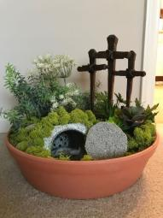
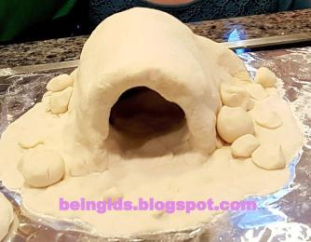
- Create an Easter hunt around your house (and garden?). See if others can follow the trail and find the treat at the end. Think about how it felt when the disciples went to the tomb and found it empty, but then met Jesus, the best gift of all!

Activities
Under 5s

Many of the crafts/activities in the previous page will work for toddlers, but we have more activities specifically for them below:

- If you have a pop up tent or one that is easily assembled, you could put it up outside or in your garden. You could put a doll in the tent initially and zip it up to represent the tomb being shut with the stone. You can then remove the doll (whilst getting your toddlers to close their eyes and pretend they’re crying like Jesus friends or else skip this first part). You then explain how Jesus friends went to see Jesus but the stone was rolled away and open the tent door and let them explore the empty tent, just like his friends would have done with the tomb.
- If you have a mud kitchen (or just an old bowl/saucepan) you could create some mud, gather sticks, leaves, stones etc and make a tomb on a tray. You can talk about the fat that the tomb represents a sad part of the story, but also a very happy part, because Jesus overcame death and rose back to life when his friends saw the stone was rolled away.

- Have an Easter egg hunt. Talk about how, just like the kids were very excited to find eggs, Jesus friends were even more excited when they went to Jesus tomb. Then open/crack the egg and explain that, just as the egg is empty so was the tomb when Jesus friends went to visit it, because Jesus wasn’t dead anymore, He was alive!

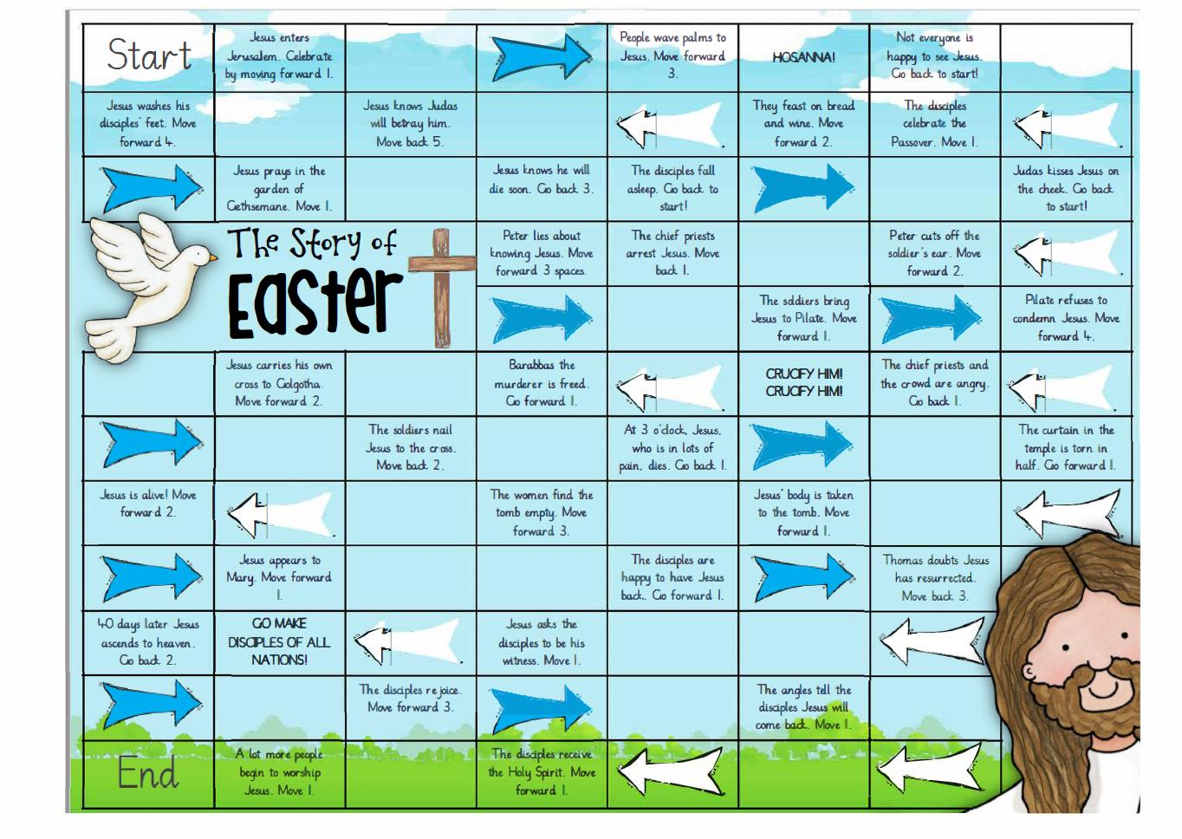
A game to play with your family. All you need is a dice and some counters.

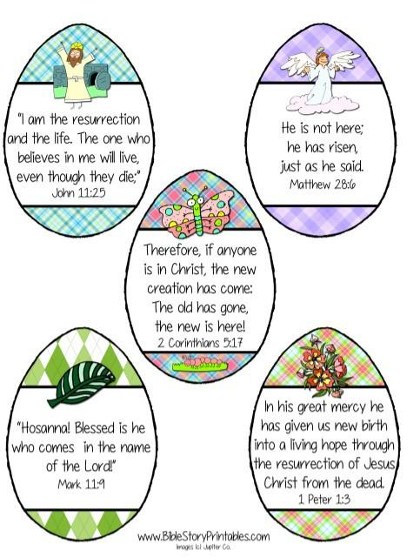

Cut out and sequence into the correct order to tell the aster story

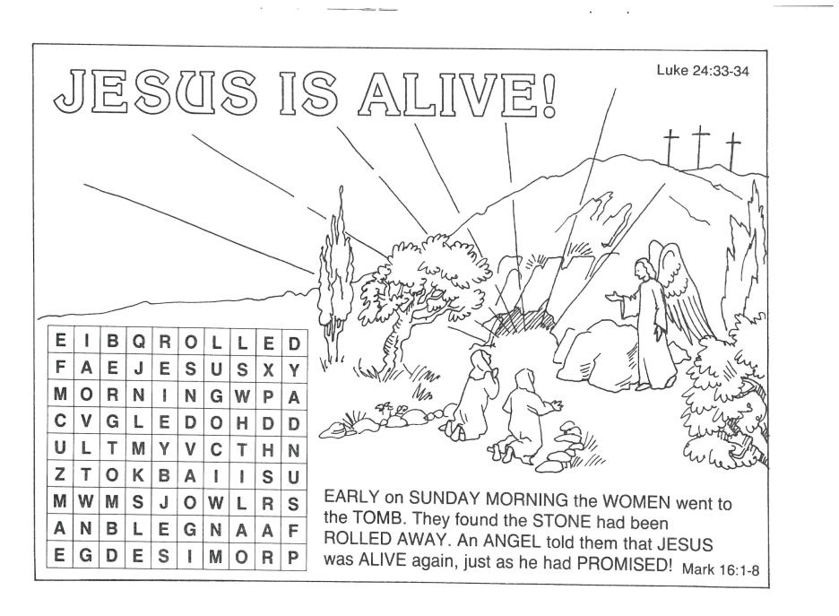
Puzzles

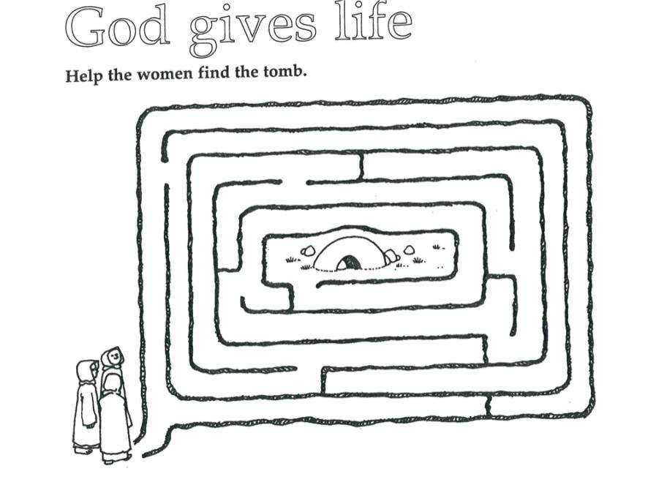

Colouring in

